Software Architecture and Design Specification
Project: Hospital Management System
Version: 1.0
Authors: Team 14 - Nirav Choudhary, Pranav Kaushal, OP Medha, Pranav Swaroop
Date: 04-10-2026
Status: Draft / Mini-Project Submission

Revision History
Version | Date | Author | Change Summary
Version | Date | Author | Change Summary
1.0 | 06-09-2026 | Team 14 | Initial SRS document
1.0 | 16-09-2026 | Team 14 | Architecture & design document
1.0 | 04-10-2026 | Team 14 | SAD template completed for submission

Approvals
Role | Name | Signature/Date
Role | Name | Signature/Date
Team Member | Nirav Choudhary
Team Member | Pranav Kaushal
Team Member | OP Medha
Team Member | Pranav Swaroop

1. Introduction
1.1 Purpose
This document specifies the architecture and software design of the Hospital Management System (HMS), showing how the requirements are divided into components, how those components interact, and how the main functions handle normal and error conditions.
1.2 Scope
The design covers authentication, patient management, doctor management, appointments, billing, reports, administration, storage, input validation, and role-based access. Advanced hospital equipment and external insurance integration are outside the scope of the basic system.
1.3 Audience
Developers, testers, hospital staff, administrators, project evaluators, and maintenance teams.
1.4 Definitions
HMS - Hospital Management System; Patient - person receiving hospital services; Doctor - medical professional providing consultation; Admin - user responsible for managing system data; Appointment - scheduled consultation between a patient and doctor; RBAC - role-based access control; CLI - command-line interface.

2. Document Overview
2.1 How to use this document
This document describes the HMS architectural pattern, major components, component responsibilities, requirements traceability, security architecture, detailed data structures and functions, UML sequence flows, error handling, storage design, and security/quality traceability.
2.2 Related Documents
Hospital Management System SRS v1.0 (Team 14); Hospital Management System Architecture & Design v1.0 (16-09-2026); source repository: github.com/Nirav6769/Hospital-Management-System.

3. Architecture
3.1 Goals & Constraints
Goals: clear separation of concerns; protection of patient information; prevention of invalid, duplicate, and conflicting records; reliable persistence; simple and lightweight operation suitable for the mini-project. Constraints: small C/C++ desktop application; basic version does not require network communication; storage may use local files or a database; only dummy/test patient data is used during development and testing.
3.2 Stakeholders & Concerns
Patients: confidentiality and correct appointment information. Doctors: access to assigned schedules and relevant patient information. Receptionists: efficient patient registration and appointment management. Administrators: user/doctor management, records, reports, and auditability. Developers and testers: modularity, maintainability, correctness, and demonstrable test coverage. Evaluators: traceability from SRS requirements to architecture/design.

3.3 Component (UML) Diagram

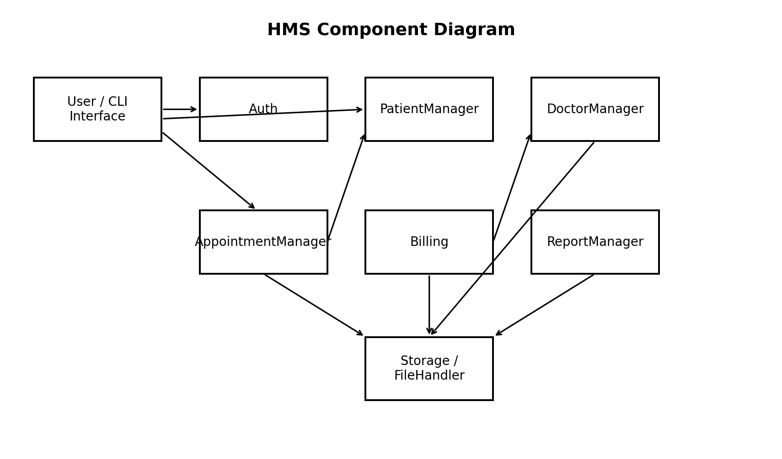

3.4 Component Descriptions
3.4 Component Descriptions
- User / CLI Interface: provides menus, prompts, input collection, and output display.
- Auth: handles username/password login and identifies the user role.
- PatientManager: registers, updates, and searches patient records.
- DoctorManager: adds/updates doctor information and checks doctor availability.
- AppointmentManager: creates, cancels, and reschedules appointments and prevents double booking.
- Billing: stores basic billing information for a patient visit.
- ReportManager: generates simple patient and appointment reports.
- Storage / FileHandler: provides a common interface for reading and writing persistent data.

3.5 Chosen Architecture Pattern and Rationale
Layered architecture is chosen because it fits the small C/C++ desktop application described in the SRS and separates user interaction, business rules, and persistence. This keeps modules easier to understand, test, and maintain. A microservices approach would add unnecessary deployment and communication complexity for the mini-project.

3.6 Technology Stack & Data Stores
Technology: C / C++. Presentation: simple CLI/menu layer. Business layer: Auth, PatientManager, DoctorManager, AppointmentManager, Billing, and ReportManager. Data access: Storage / FileHandler using local files or a database as permitted by the SRS. Communication: none required in the basic version; authenticated communication would be used for a future network deployment.

3.7 Risks & Mitigations
Risk: persistence failure or inconsistent records -> Mitigation: isolate persistence in Storage / FileHandler, reject corrupted/unknown reads, report write failures, and preserve the previous valid state where possible.
Risk: unauthorized patient-data access -> Mitigation: authentication, role-based authorization, and restricted record access.
Risk: invalid or duplicate data -> Mitigation: validate inputs and unique identifiers before storage.
Risk: appointment double booking -> Mitigation: check the doctor/time slot before saving the appointment.

3.8 Traceability to Requirements
HMS-F-001 (login) -> Auth.
HMS-F-002 to HMS-F-004 (patient registration, update, search) -> PatientManager.
HMS-F-005 to HMS-F-007 (doctor management and availability) -> DoctorManager.
HMS-F-008 to HMS-F-012 (appointment lifecycle and schedule) -> AppointmentManager.
HMS-F-013 (billing) -> Billing.
HMS-F-014 (reports) -> ReportManager.
HMS-F-015 (user accounts) -> Auth + User Administration.

3.9 Security Architecture
Security controls are applied before protected business operations. Authentication provides a username/password gate; role-based authorization determines permitted menus and functions; input validation runs before storage; patient records are returned only after an access check; important administrative actions such as user creation and record deletion are recorded. Threat-oriented controls include spoofing resistance through authentication, tampering resistance through validation and controlled updates, information-disclosure reduction through role checks, denial-of-service resistance through input validation/lightweight operations, and privilege-escalation resistance through RBAC.

4. Design

4.1 Design Overview
The HMS follows a simple layered design. The Presentation / CLI Layer handles menus, prompts, input and output. The Business Logic Layer enforces authentication, authorization, validation, scheduling, billing, reporting and other application rules. The Data Access / Storage Layer reads and writes persistent records through Storage / FileHandler. This matches the existing Team 14 architecture document.

4.2 UML Sequence Diagrams
Two sequence flows are included: (1) Patient Appointment Booking, where availability is checked before saving the appointment; and (2) User Authentication & Role-Based Menu Dispatch, where credentials are verified, the role is determined, and the permitted menu is displayed.
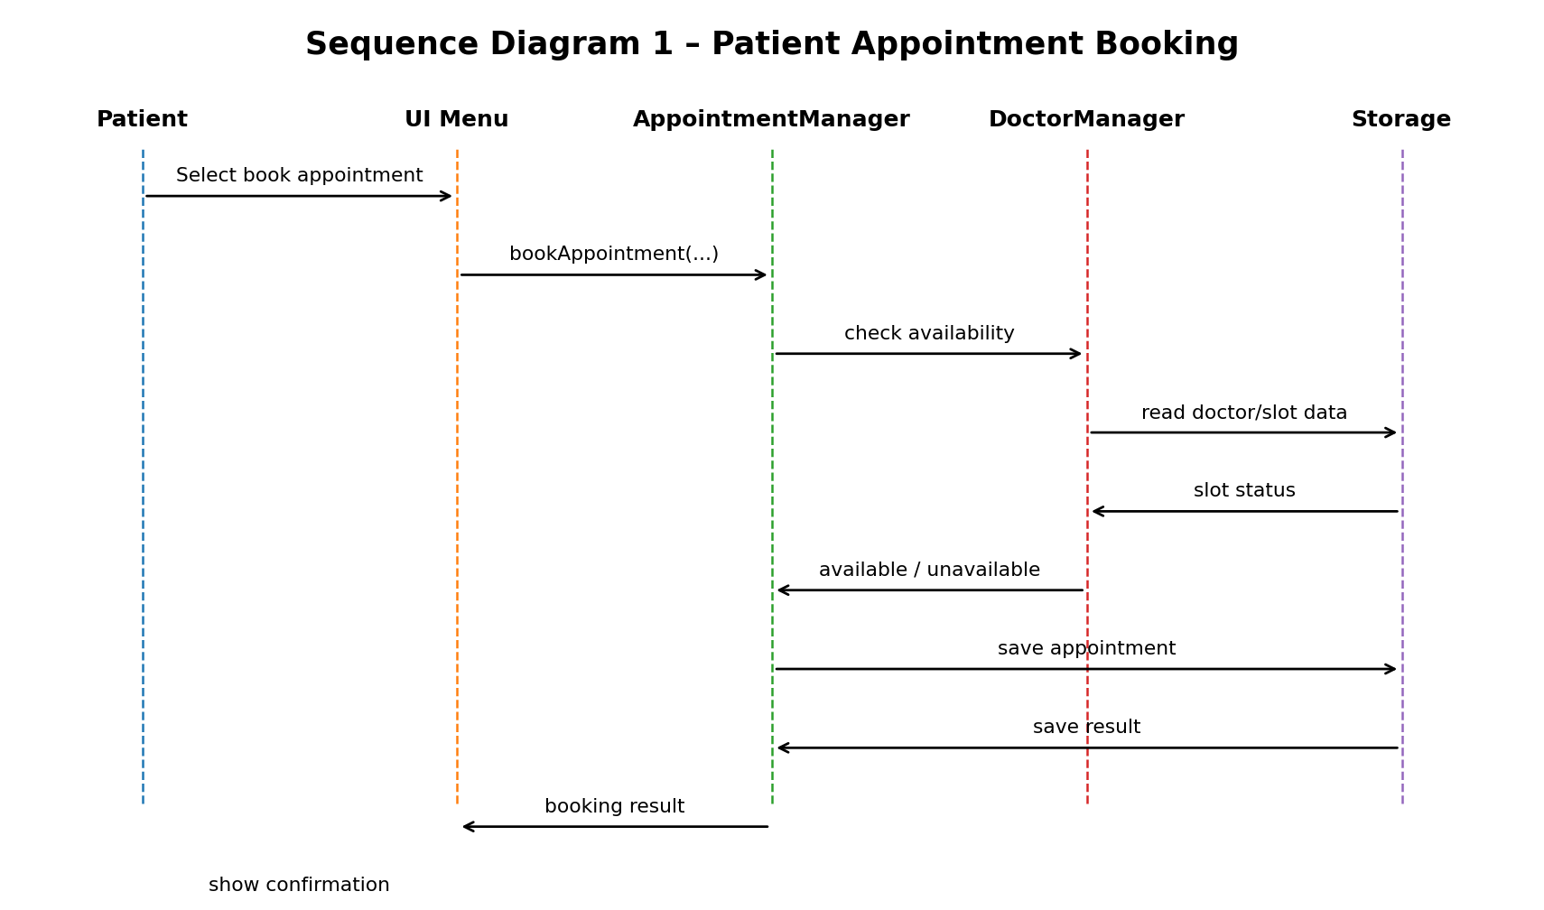
Sequence Diagram 2 - Authentication & Role-Based Menu
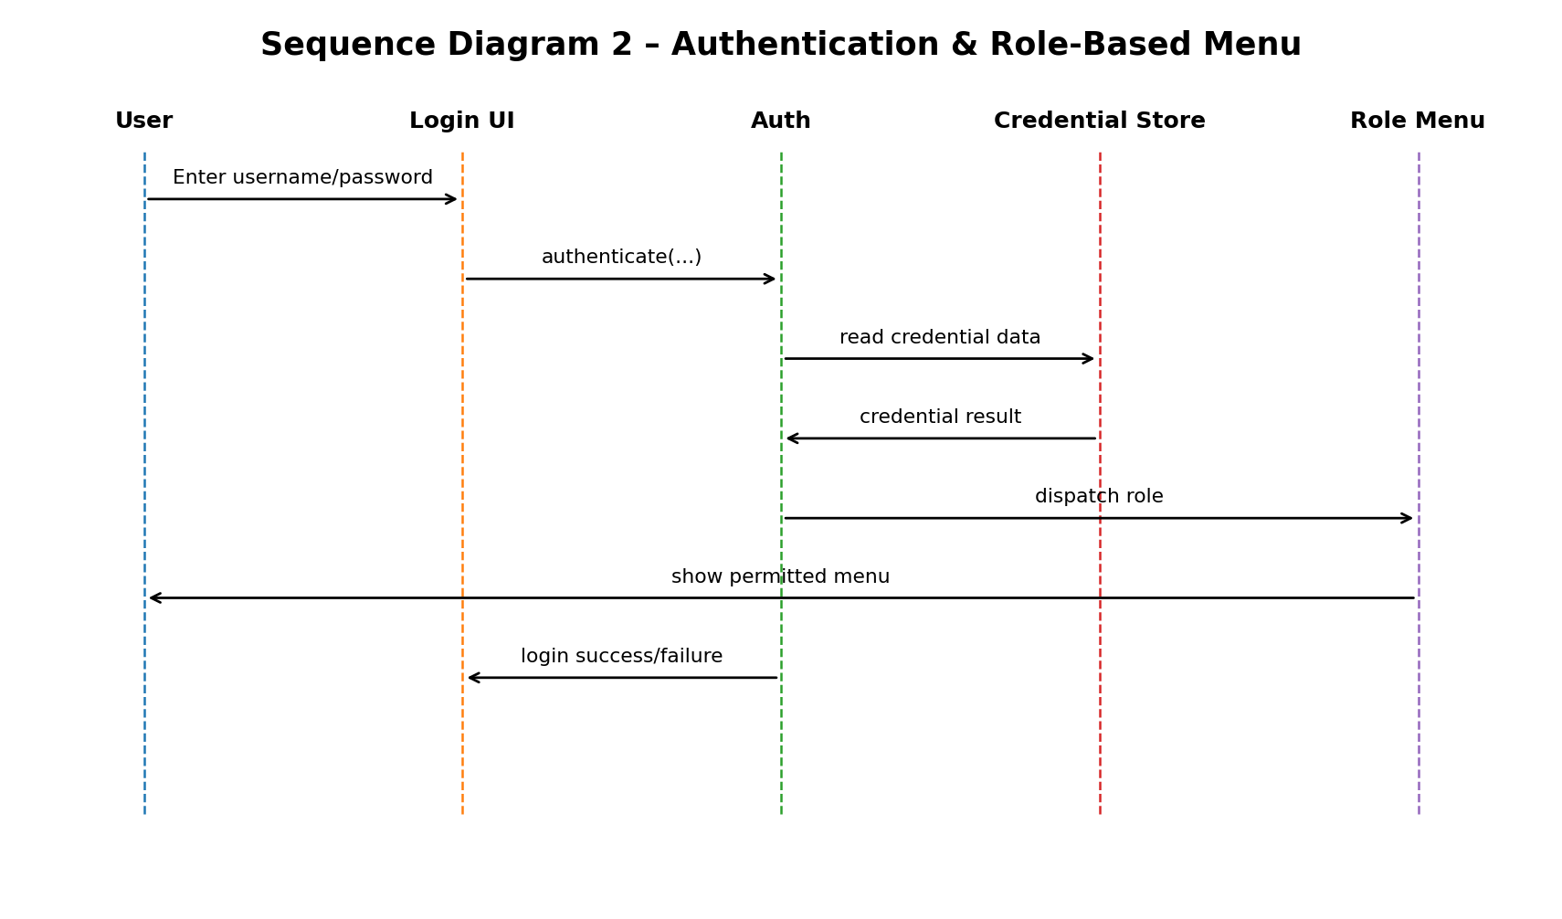

4.3 API Design
Core component interfaces are defined by these functions:
- authenticate(username, password) -> bool: checks credentials and allows/denies login.
- registerPatient(patient details) -> Patient: creates a patient record with a unique ID.
- searchPatientByID(id) -> Patient / not found: finds a patient by ID.
- updatePatient(id, patient details) -> bool: updates an existing patient.
- addDoctor(doctor details) -> Doctor: adds a doctor record.
- updateDoctor(id, doctor details) -> bool: updates doctor details.
- isSlotAvailable(doctorID, Slot) -> bool: checks whether a doctor/time slot is free.
- bookAppointment(patientID, doctorID, Slot) -> bool: creates an appointment if the slot is available.
- cancelAppointment(appointmentID) -> bool: cancels an existing appointment.
- rescheduleAppointment(appointmentID, Slot) -> bool: moves an appointment to a valid free slot.
- saveBill(Bill) -> bool: stores billing information.
- createUser(User) -> bool / disableUser(username) -> bool: manages administrative accounts.
- generateReport(report type, filters) -> Report: creates a simple report.
Endpoint: /withdraw
Method: POST
Request: {cardId, pin, amount}
Response: {status, balance}
Errors: 401 Invalid PIN, 402 Insufficient funds.

4.4 Error Handling, Logging & Monitoring
Errors are handled explicitly and without reporting false success. Empty required input is validated before business calls. Invalid IDs produce a not-found error without modifying data. Invalid date/time values are rejected. Double booking is rejected after checking the doctor/time slot. Unauthorized roles are denied protected operations and returned to the permitted menu. Duplicate patient/user records are rejected. File/database read failures return a storage error and do not continue with corrupted or unknown data. File/database write failures return failure status and preserve the previous valid state where possible. Suggested values: OK = 0, INVALID_INPUT = 1, NOT_FOUND = 2, UNAUTHORIZED = 3, DOUBLE_BOOKING = 4, DUPLICATE = 5, STORAGE_ERROR = 6. Important administrative actions are recorded, while sensitive patient information is not placed in logs.

4.5 UX Design
The CLI should use simple menus, clear prompts, short error messages, and predictable navigation. Only functions permitted for the logged-in role should be displayed or accepted. This supports the SRS usability requirement that menus and messages be simple and understandable for hospital staff.

4.6 Open Issues & Next Steps
Open issues / next steps: complete and validate the implementation against the full SRS; expand test coverage; verify storage/restart behavior; tighten separation between storage and business logic; and consider a database-backed or networked deployment only as a future enhancement. The present design intentionally remains a small desktop system for the mini-project.

5. Appendices
5.1 Glossary
HMS - Hospital Management System.
RBAC - Role-Based Access Control.
CLI - Command-Line Interface.
SRS - Software Requirements Specification.
SAD - Software Architecture and Design Specification.
ADR - Architecture Decision Record.
5.2 References
Hospital Management System SRS v1.0, Team 14, 06-09-2026.
Hospital Management System Architecture & Design v1.0, Team 14, 16-09-2026.
GitHub repository: Nirav6769/Hospital-Management-System.
5.3 Tools
C / C++; GitHub; UML/component and sequence diagrams; local file/database storage abstraction.

